Ballantrae Festival of Food & Drink 2019: Independent Economic Evaluation

Final Report
July 2019

Contents

Section Page

Executive Summary i

Introduction 1

The Visitor Survey 1

Economic Impact Assessment 4

Traders’ Survey 5

Further Business Feedback 9

Annex A a

Annex B i

Executive Summary

The Ballantrae Festival of Food & Drink was held on 8th and 9th June 2019. The 2019 festival once again celebrated the local produce and the coastal heritage of Ballantrae in South Ayrshire, and attracted a total of 2,800 visitors. A visitor survey was carried out to ascertain the impact of the festival on the local economy. It helps to demonstrate the ‘success factors’ and ‘lessons learned’ to support the development of future events.
The survey found that 34% of the respondents to the visitor survey were from the Ballantrae area, with 32% from elsewhere in Ayrshire, 29% from elsewhere in Scotland, 4% elsewhere in the UK and 4% from outside the UK. This finding suggests that although there was a strong local attendance profile, the event successfully attracted a large number of people from outside the local area.
‘Word of Mouth’ was noted as the most popular marketing source, closely followed by followed by ‘Facebook’. Other popular responses included ‘Leaflet’, ‘Roadside banner’, ‘Local Newspaper or Magazine’ and ‘Poster’. This suggests the event was well marketed and visitors were aware of the event from a number of different sources.
Overall, 81% of respondents were not staying away from home as part of their trip to the event. 9% were staying in self-catering, 8% were with friends or family while 2% were in a hotel or B&B. Of those staying away from home the average duration of their stay was 5.4 nights, suggesting there were a number of holiday makers in the area taking in the festival as part of their trip.
68% of respondents noted that the Ballantrae Festival of Food & Drink was ‘Very Enjoyable’, and only four respondents noted the event as ‘Not Enjoyable’.
Overall 71% of respondents were interested in receiving information about future events, confirming that event-goers are keen to be kept informed about future events in the area.
The net additional economic impact of visitor spend as a result of the Ballantrae Festival of Food & Drink was in the range of between of £115,497 and £146,593.
A survey of businesses that traded at the festival was also completed, this found that 53% noted that the event had a ‘Very Positive’ economic impact on their trading position and 29% claimed the impact to be ‘Positive’. 42% of the traders noted that this level of financial impact was better than that achieved at comparable events over the last two years.
30% of firms noted that their financial expectations were either ‘A lot better’ or ‘better’ than expected as a result of trading at the Ballantrae Festival of Food & Drink.
71% felt that the village’s hosting of the Ballantrae Festival of Food & Drink encouraged them to think about new ways to develop or promote their business, product or service.
A range of other local businesses were also interviewed as part of this assessment, where 11 local businesses were willing and able to provide a supportive testimonial around the hosting of this years Ballantrae Festival of Food and Drink.
Overall, the fourth hosting of the Ballantrae Food and Drink Festival can be deemed a huge success, having not being hosted in 2018. The economic impact is notable, approaching £150k for the two-day event. Qualitative feedback from visitors, traders and local businesses was also very positive and their feedback can be used to grow the event further in future years.

Introduction

The Ballantrae Festival of Food & Drink was held on 8th and 9th June 2019. The 2019 festival once again celebrated the local produce and the coastal heritage of Ballantrae in South Ayrshire, and attracted a total of 2,800 visitors. This was the fourth Festival to be held, the first one being held in 2015 (there was no Festival in 2018)
The Festival was created to encourage visitors to Ballantrae to enjoy local and regional artisan food and drink produce and to also encourage suppliers to come to Ballantrae to support the Farmers Markets that were being established in the village. The Festival and Markets have between them made Ballantrae a place that suppliers and stall holders want to go to.
The Visitor Survey

A visitor survey was carried out to ascertain the impact of the festival on the local economy. It also helps demonstrate the ‘success factors’ and ‘lessons learned’ to support the development of future events.
The self-completion visitor survey was conducted during the event and attendees were encouraged to complete the survey during their visit and also through Facebook and Twitter after the event. The survey was designed to capture information about the attendees’ demographics, reasons for visiting, spend patterns and perceptions about the festival.
In total 542 attendees completed the survey. 542 completed surveys from a total estimated population of 2,800 visitors gives a level of accuracy at the 90% confidence level of ±3.2%.
The following figure highlights that 34% of the respondents to the visitor survey were from the Ballantrae area, with 32% from elsewhere in Ayrshire, 29% from elsewhere in Scotland, 4% elsewhere in the UK and 4% from outside the UK.
This finding suggests that although there was a strong local attendance profile, the event successfully attracted a large number of people from outside the local area.
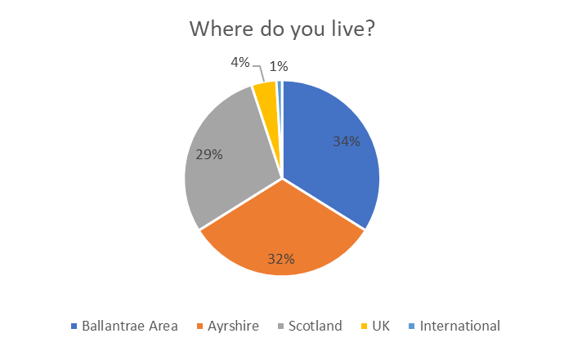
The figure overleaf shows the origin of non-local UK visitors to the event, in terms of overseas visitors, these came from France, the Channel Isles, the USA and Ireland. The map shows that the festival had a reach across the UK, notably the central belt of Scotland, Dumfries and the north of England.

Map of Non-Ayrshire Visitors from the UK
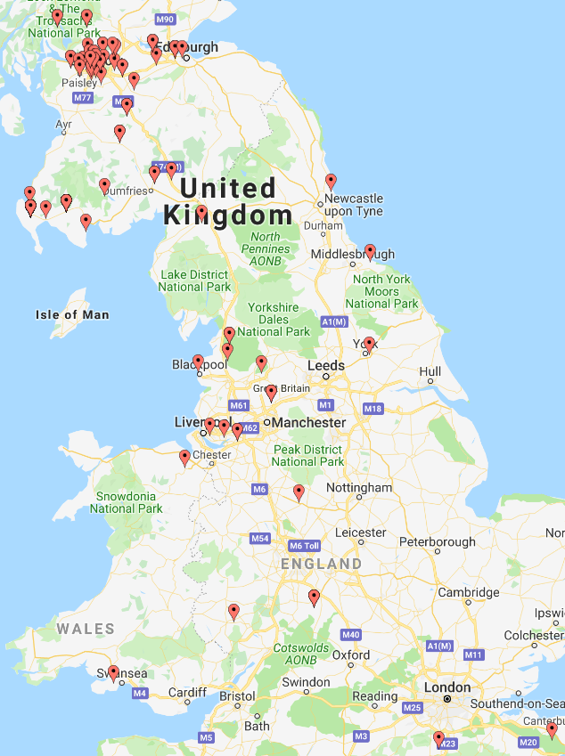
Visitors were asked to identify which marketing sources attracted them to the festival, as they were asked to mention all sources, these percentages represent the percentage of the respondents which quoted the quoted source, for example 45% of the sample identified ‘Word of Mouth’ as a marketing source.
As noted above, ‘Word of Mouth’ was quoted by 45% of respondents as a marketing source followed by ‘Facebook’ quoted by 44%. These were the most popular methods of finding out about the event. Other popular responses included ‘Leaflet’, ‘Roadside banner’, ‘Local Newspaper or Magazine’ and ‘Poster’. This suggests the event was well marketed and visitors were aware of the event from a number of different sources.
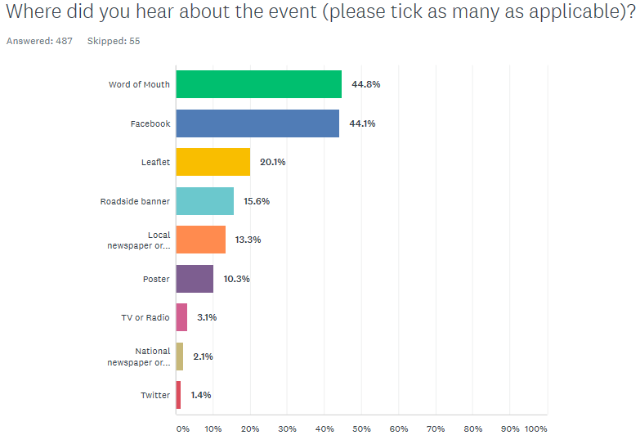

Overall, 81% of respondents were not staying away from home as part of their trip to the event. 9% were staying in self-catering, 8% were with friends or family while 2% were in a hotel or B&B.
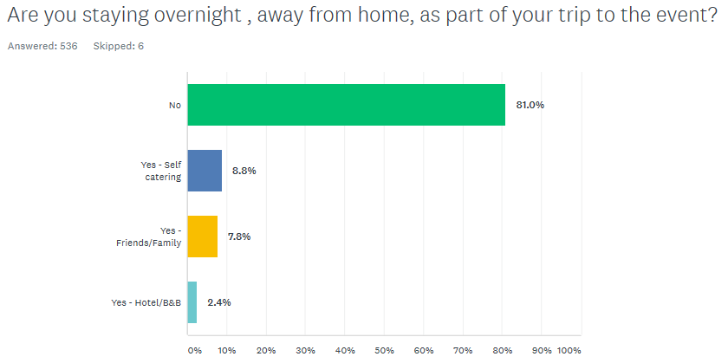
Of those staying away from home the average duration of their stay was 5.4 nights, ranging from one night to two months, suggesting there were a number of holiday makers in the area taking in the festival as part of their trip.
The average party size was 3.2 people, suggesting people visited in groups with some people travelling in groups of up to ten people.

When asked what visitors felt about the event, 68% of respondents noted that the Ballantrae Festival of Food & Drink was ‘Very Enjoyable’, and only four respondents noted the event as ‘Not Enjoyable’.
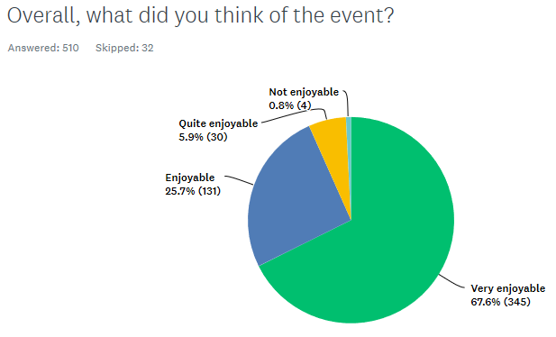

A wide range of responses were provided when people were asked ‘what was the best thing about the Ballantrae Festival of Food & Drink?’ The most popular responses included Variety of Stalls (quoted by 96 people), The Atmosphere (quoted by 86 people), The Music (quoted by 50 people), The Food (quoted by 46 people) and The Gin (quoted by 39 people). A full set of individual responses is provided in Annex A:
There was a very wide range of comments provided about how the event could be improved in future, these tended to be associated with the layout of the venue in terms of the location of stalls and seating and a full set of responses is provided in Annex B. These can be used to enhance the event further in future years.
Overall 71% of respondents were interested in receiving information about future events, confirming that event-goers are keen to be kept informed about future events in the area.

Economic Impact Assessment

Importantly for economic impact analyses, visitors were asked how much they had spent per person in attending the event, not including entry. The total average spend per visitor during the event was estimated to be in the region of £31.73 (ranging from £1 to £130)
In terms of grossing these results across the entire population of visitors, the estimated 2,800 visitors to the festival injected £88,844 to the local economy. The expenditure on staging the event will also have had two types of wider impact on the economy:
- Supplier effect: an increase in sales in a business will require it to purchase more supplies than it would have otherwise. A proportion of this ‘knock-on’ effect will benefit suppliers in the local economy; and
- Income effect: an increase in sales in a business will usually lead to either an increase in employment or an increase in incomes for those already employed. A proportion of these increased incomes will be re-spent in the local economy.
There are a number of multipliers which can be used, including the Scottish Tourism Multiplier Study (STMS) which provides standard supplier and income multipliers for the tourism sector. This estimates that the combined supplier and income multiplier for a rural location is 1.65 at the local level. The Scottish Government also publishes Input:Output Tables on an annual basis, and although it does not categorise ‘Tourism’ there is a ‘Food and Beverage Services’ category, which has an income multiplier of 1.30.
This suggests that the net additional economic impact of visitor spend as a result of the Ballantrae Festival of Food & Drink was in the range of between of £115,497 and £146,593.
Adopting standard spend: employment assumptions, where 1 tourism related job is safeguarded for every £54,000 of visitor spend, the event helped safeguard up to three tourism related jobs. This is an impressive outcome considering the event is run only over two days.

Traders’ Survey

Businesses that traded at the Ballantrae Festival of Food & Drink were asked to provide feedback on the event. The following (17) businesses provided feedback:
- Selkirk Distilleries
- Jan De Vries Healthcare
- Stonehouse Pet Care
- Home Energy Scotland
- A.D.Rattray
- The Little Bakery
- Pixel Spirits
- salt pig sea salts
- Homemade By Jill
- Ayrshire Hampers
- CO CO CO
- Oishii
- Cairn o Mohr Ltd
- Jeju's Bakehouse
- THREEPWOOD FAYRE
- Go Fly Your Kite
- Ballantrae Trust

The following methods of hearing about the event were provided:
- Email from event organisers
- Through Marie coming into the shop
- Word of mouth and attended with my stall first two years
- Been here in previous years
- Attending and trading since the first Festival
- From attending Ayr Farmers market
- Chris Hannah
- Social Media Posts
- Newmilns food festival
- Previous owner provided details
- Had applied previously
- Word of mouth (Lynn at Everything Chilli)
- Food From Fife event
- Internet
- Been twice before
- Email from Anna having seen us at Stranraer Oyster Festival
- Local information

Nine of the traders (that completed questionnaires) (53%) noted that the event had a ‘Very Positive’ economic impact on their trading position, five traders (29%) claimed the impact to be ‘Positive’, one trader noted the impact as ‘Negligible’, one as ‘Negative’ and one as ‘Very Negative’. The level of financial impact ranged between £200 and £2,000, with an average financial impact of £730.

The figure below highlights that 42% of the traders noted that this level of financial impact was better than that achieved at comparable events over the last two years. This table does not add up to 100% due to rounding.
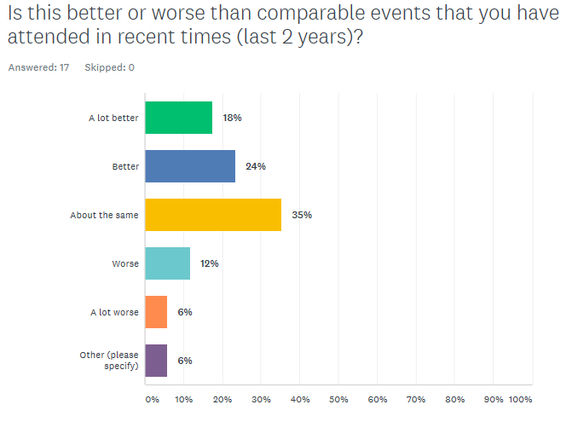

The figure below shows that 30% of firms noted that their financial expectations were either ‘A lot better’ or ‘better’ than expected as a result of trading at the Ballantrae Festival of Food & Drink.
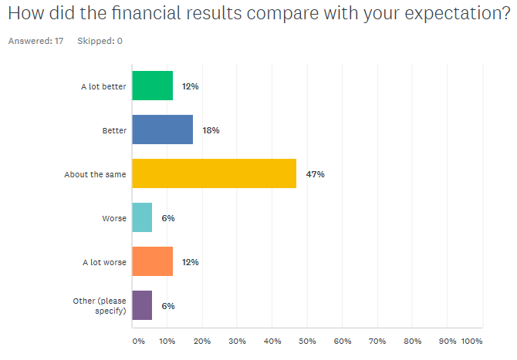

12 traders (71%) felt that the village’s hosting of the Ballantrae Festival of Food & Drink encouraged them to think about new ways to develop or promote their business, product or service. Examples of new ways included:
- Better point of sale
- Probably having the tastings of different healthy foods
- New area and different customer base
- We Intend to trade at more events like Ballantrae
- Contacted by New potential Retailers
- Do more food only events
- Though we mainly sell individual items at events, we see that at least having a range of hampers on display helps show customers what we do and encourages sales after the event.
- I met a fellow stall holder who would like to stock my dressing (in Jan de Vries)
- I have had people contacting me for orders after the event & also satisfied customers sharing their opinions on my products on social media
- Our kite business is a unique activity and it is great to build up a network of customers past and future who would be interested in our workshops.

Six of the traders (35%) noted that they had run special marketing, promotions or incentives around the period of the Ballantrae Festival of Food and Drink. Examples of special marketing included:
- 10% off our shop
- Prize draw and smoothie making bike
- Creating and promoting of a limited edition Smugglers Whisky for the Festival
- Discount on multi PRODUCT PURCHASES
- Two white wines for £10 (normally at least £7.50 each).
- Multi-buy offers

Four of the 17 traders stayed overnight in paid accommodation as part of their trip to the event, suggesting they made a positive economic impact in their own right to the local economy.

When asked ‘How could trading at the Ballantrae Festival of Food & Drink be changed to more directly benefit your business?’, the following responses were provided:
- I don't think it should be changed. It went from 1 to 2 days of festival and that is sometimes risky as 1 day might be much better than the 2nd. Many people who have never visited the shop but drive by on a daily base had the chance of a chat to find out what we are doing and now are visiting the shop
- No change
- I'm not sure much could be changed. It's well advertised to encourage visitors to come.
- By not charging an entrance fee you may attract more customers who would perhaps spend more and be less interested in what 'free' samples there were on offer.
- Higher footfall, other events on locally on the Saturday
- I don’t believe there was anything that needed changed as our space was excellent and the volunteers were very friendly indeed!

When asked ‘What was the best thing about trading at this year’s Ballantrae Festival of Food & Drink?’, the following responses were provided:
- A positive vibe throughout the event
- The customers and the music. The views of the shore.
- The weather was kind, great layout, space between stalls was fab, selection of businesses was good, large tables are great, great and strong marquee and music was great (not too loud and not too quiet)
- Changed from 1 to 2 days and the variety but still relevant traders to a food festival
- The atmosphere
- It was an amazing and well planned event. Everyone had a great time. There was a wide range of activities and producers to keep everyone happy.
- Future Business Potential
- Ease of unloading and loading; friendliness of the Ballantrae team
- The event was well run and is in a great setting.
- Lovely setting.
- Great atmosphere and bustle, lovely location, really well organised. I honestly don't have a bad word to say about the event. Only wish I’d come along for 2 days instead of 1.
- It is a lovely event and the organisers and other traders were also lovely. A positive experience
- Brilliant organisation & location. Also the type of stalls present were great too!
- Good atmosphere
- Honestly, meeting all the people and the great feedback about our kite workshops
- Meeting people and chatting

When asked ‘How would you change Ballantrae Festival of Food and Drink to encourage you to continue to trade at the event’, the following responses were provided:
- Looking forward to next year already
- I think it is great as it is.
- As long as it as well promoted and visited, we will continue to be part of it
- Nothing
- We would be delighted to attend again and to even to make another batch of gin for the festival. However, we would have to look into how to do it more profitably as all profits from the 2 batches of gin were eaten up by the van hire, accommodation, petrol, stand cost etc. This is mostly my own fault as I should have looked into these things more carefully.
- Move the Music Stage to another part of event, 1st day had to shout to customers and vice versa this had effect on trade was slightly better 2nd day, Band were very good
- No change
- Can't think of anything. We'd love to come back next year!
- I honestly can't think of anything I'd change. The organisers did a great job!
- It just needs to be bigger or attract more footfall.
- Trade on one day only and with no other competing events on the same day
- Perhaps the flow of getting to the workshop could be more visual easier to find but apart from that it was a fabulous experience! Thank you for having us !
- Suggestion of more seating. There were very limited outdoor seating and people were ready and wanting to rest

Further Business Feedback

A short survey of other local businesses was undertaken, this was led by the Ballantrae Trust, with the following feedback from local businesses after the event:
- Kings Arms Hotel – One stallholder booked a room and there were several festival goers in the pub after the festival on Saturday
- Craigiemains Garden Centre – Very Busy
- Shellknowe Garage – they were closed over the weekend but credit card petrol sales were increased.
- BRICC - ~£400 on the stall taken on the Sunday. Sales in the shop were up £200 per day
- Laggenhouse Country Park – no additional sales etc
- SCOTMID – no additional sales
- Ballantrae Holiday Cottages – Bookings taken specifically for the festival
- Glenapp – “Made money” – worth attending the event
- Bennane Shore Holiday Park – additional visitors at Pebbles in for food
- Colmonell Fun day – numbers weren’t affected by the festival and a good time had by all.
- Ballantrae Baking (on behalf of the Church) – they took in over £800 so a huge success.

Add a heading Feedback From Visitors Questionnaire
Annex A: What was the best thing about the Ballantrae Festival of Food and Drink
- Live music and children's kite making
- Sampling goods that I've not seen in shops
- All the tastings in order to purchase
- Atmosphere and food
- Food, band, company
- "Good atmosphere
- Good music"
- The different selections on Gin!
- Happy atmosphere
- Selection of food/drink on offer
- Kite flying
- Kite flying
- Variety of stalls
- Kite flying
- "All the stalls
- Brilliant!"
- Food and drink
- Good variety of stalls - drunks not expensive, good music throughout
- Great sauce of country
- Hospitality and friendliness
- Being able to taste new things
- Great location
- Trying and tasting
- Range of stalls
- Location and food tasting
- Atmosphere
- Really really disappointed- for £4 per person, rip off.
- Relaxing atmosphere, good music, reasonable prices
- Variety of stalls and Ballantrae gin!
- Taste before you buy
- Food
- People selling
- music
- EVERYTHING
- demos, Massi Lisis demo, and band
- cocktail demo
- demos in tent, for a small village great event!
- the atmosphere, variety of stall selling local produce
- demonstrations
- cookery demo
- day out
- day out
- the tasting
- taste and try, weather was ok
- taste and try
- samples
- variety
- wooden floor- wife being in a wheel chair
- lovely community atmosphere
- pies!
- various unusual stuff for sale
- wine tasting, live music
- sample before buying to see if you like the product
- all very good
- making a kite
- the setting and choice of stalls
- tasting food
- variety of natural produce and gin fest
- seeing all the local products
- Meeting friends. Tartry
- Good range of food and drink
- Lots of people attending and sunshine
- Free samples
- Brie
- The variety of food and drink on offer
- Live music, separate demo test, complementary water
- Atmosphere and the unexpected discovery
- Introduction to new foods and friendly atmosphere
- It was all superb
- Music, food and drink
- Choice of products
- Hog roast
- "Friendly atmosphere
- Variety of food and drink"
- Food, music, gin
- variety of girls
- the music and friendliness
- Local produce
- variety of stalls
- Food and entertainment
- The music
- hairy steak burgers, music
- The stall holders were very helpful
- Enjoyed the demonstrations and testing all different things at the stalls
- the variety of products and larger seating areas to enjoy the bans, food and bars!
- It is happening. Well done!
- kites, cheese, food demos
- Local produce and companies we didn't know
- Ambience and local friendliness
- Loved the live music. Great atmosphere
- well laid out
- Food and drink stalls/music/beach
- space to move around and see what was for sale, good variety of produce
- The variety of stalls/food retailers
- a good mix of food and drink
- interesting food stalls, meeting new friends
- Lots of different gins!!
- Trying different foods
- Good variety of food
- trying things and the friendliness
- Good choice of local produce
- Kite designing
- GIN
- Kite design
- choice of food and drink
- All good
- gin tasting!!!
- Kites
- Free testers
- all good
- Enjoyable family day
- the variety of food and the seize of community
- All of it
- variety of foods
- Variety of stalls
- variety of gin
- The variety was good
- variety
- The pizza
- totally over priced, to go around a small tent, very very disappointed. travelled two hours!!
- Sampling different food and drinks
- able to sample before buying
- great time through out
- Meeting real producers
- the spirits
- Setting beautiful
- atmosphere
- Local businesses are able to reach new customers
- atmosphere and the tasting
- Giving small local businesses platform
- variety of stalls and friendly people
- Smoked seafood
- choice of stalls
- more space and choice of stalls, kite flying to
- variety of stalls available
- flying elephants
- whiskey
- the variety of food and drink ant the friendliness of the people.
- a good selection of different food and drink and lots of sampling
- all good
- all is good
- all is good
- well organised- great food and drink
- the food and the drink!
- tasting different food
- lots of sample and leaflets
- the gin and whiskey from my birth place
- Ballantrae church stall
- Ballantrae church stall
- all undercover and ease to get around
- friendly atmosphere easy to get to.
- atmosphere friendly and stall holder, free samples:)
- discovering the wealth of local food and producers
- Ballantrae gin
- cooking demonstrations
- the food
- easy and free parking
- cakes
- great music, great smells, tastes, community spirit with warn welcome
- various- location-music-Dumfries pie
- first visit
- wide variety of food
- first visit
- wide choice of food
- locals friendly and produce
- lots of yummy samples, spent a fortune
- food and music
- local fayre
- free samples
- visit 1st great variety
- variety
- promise to return 2020
- Great day out - brilliant atmosphere
- Stall holders very helpful and band great"
- great audience, good food, friendly people
- Variety of goods and samples
- good company get together
- lovely food, plenty stalls
- Location! Variety! Range of produce! GIN!
- wide range of stalls, chance to try before you buy, great foraging workshop
- Food selection
- Good food
- good day out
- Whisky experience
- vegetarian choices- that makes a change
- Trying all the different produce and variety of food and drink stalls
- the expectation
- Weather this year compared to 2 years ago - when last on
- The same reason we returned this year because of local produce
- being able to talk to producers about there products
- Local produce
- The atmosphere
- plenty of variety
- Local produce
- doggy deli
- Friendly no rush atmosphere
- Glenapp
- Taste before buying, especially drink
- tasting
- Getting to try some samples before purchase
- the vibe
- fresh and local produce
- free samples and the music
- Everything
- the atmosphere
- Ann
- the gin and kids kite workshop
- Food and drink tasting, good atmosphere
- wide variety of stall/ samples
- Tasting drinks and food, stall holders to friendly and chatty
- GIN
- Ballantrae gin
- DRINK
- Variety of stalls, location and water on the tables
- the table and choc mint chocolate square
- The selection of hot sauces
- the sin tasting
- Seeing a sampling the best of produce Lora lyl. An excellent community event
- the music and pork rolls! :)
- Fantastic variety !
- atmosphere
- Good variety on display
- Everything. Lots of variety
- lovely atmosphere
- "Tasters before buying
- Good career"
- Choice and variety. Music
- venue, atmosphere, lots of seating, great idea providing local transport
- Beer and music
- variety of food local et
- the variety of stalls
- it was awesome, great job
- Hog roast rolls
- Ability to buy fresh local produce"
- Range of producers, introducing to previously unknown suppliers.
- Hog roast rolls - 5 star"
- live food, good variation of drink
- Interesting talking to local producers and finding local businesses we didn't know about
- white pudding and soda scones
- the atmosphere and music
- Very informative on local produce
- Ballards hog roast
- the gin, music and atmosphere
- soda scones, cheese. lots of tasters and company's
- Good atmosphere, good food
- The variety of foods available
- soda scones and the company
- Tastings
- the music and variety of stalls
- "Atmosphere-busy, friendly.
- Choice of stalls"
- music
- Good whisky
- kite making
- Glenapp chefs presentations
- Plenty of choice
- Variety on show
- the kites- the kids had a blast!! thank you
- Free samples
- demonstrations
- The gin and the kids kite workshop
- demonstrations
- Location!
- Tantry
- Samples
- The variety
- music and friendly atmosphere
- The friendly people - good selection of goods
- Samples :)
- cheffie tips. :) hog roast fab:) sound sys in demos, tent lacking :(
- The drink stalls
- The music, buzz and foraging
- Foraging for food
- the venue
- all of it!!:)
- Nice atmosphere. Nice stalls. the Gin was good!
- food and drink
- food and drink
- Great atmosphere/ good stalls and Gin
- The wo of stalls
- hog roast and the GIN!
- Music and atmosphere
- The variety of quality produce
- Music, food and gin combined
- Friendly environment
- The music
- The variety of stalls on offer
- The variety and demos
- Live music
- Variety of stalls and music
- The live music
- Variety
- Smoked goods
- Reasonable pricing and friendly atmosphere exhibitors very friendly
- Kieran Hepburns singing
- The music
- Good selection of food
- Good mixed fare
- the entertainment, kids activity and the food
- range of products
- good range of products
- trying out new food and drinks
- friendly experience
- everything
- great atmosphere
- all
- the variety of different stalls available
- Music banter
- Music
- variety of food and drink
- the company stalls just prefer Sunday
- The music
- free samples and everyone very friendly
- Local produce, music
- cakes and pizza
- Very friendly! Good pizza and music
- local participants, music was great
- Making kites with grandchildren
- the welcoming atmosphere
- variety of food
- Making and flying kites; location
- live music
- the generous samples!
- Variety and quality of stalls
- New things to try
- variety of food stuff
- The demonstrations
- Cocktail demonstration by Massi Lisi
- My little boy flying a kite
- GIN
- social/ music/ food/overall atmosphere
- Demonstrations
- local event!
- Food and demonstrations
- Unfortunately we were asked to leave with our well behaved dog
- Gin!! and the atmosphere
- free gin!!
- Music, food, view
- being able to taste all the lovely produce
- The whole experience
- Seafood, gin, music
- the atmosphere diversity and enthusiasm of the stall holders
- Free samples, good local food
- The music, free samples, food vans and cakes
- Variety of food sample tasting and music
- a change to sample wholesale and local produce
- Gin, Music and atmosphere
- All of it
- friendly stall holders and organisers variety
- Very well organised
- variety of food and drink
- Lots of local produce and great variety
- lovely village and just down the road
- Variety of stalls
- all good
- all very good
- Stein kites
- friendly visitors, good food
- All V.G
- fun day
- Drink
- Demonstration
- The tasting and gluten free brownie
- All the nice food stalls and the cocktail class brill!
- Variety of food, tasting different foods and drink
- Gin
- Selection of local produce
- Gin
- Demonstrators - Gin cocktails
- Kit making thing"
- Demonstrations
- Staff really friendly and helpful
- Huge variety of stall
- Foraging
- Variety of product etc
- Demonstrations
- Varied food and drink stalls
- GIN
- Varied food and drink stalls
- atmosphere fantastic
- Enjoyable, everybody was very warm and friendly
- Food demos.
- Gin
- The kids loved the kites.
- Ad Rattery stand
- Friendly atmosphere. Good choice of good and drink to buy and enjoy on the day.
- Gin and food tasting and roast hog. Fantastic turn out to support this fantastic event
- Variety, friendliness, great food, music, drink
- food demonstrations..... leezie lundie beer on draft
- spacious marquee, smugglers whisky special edition,
- Ballochmyle cheese, kite making
- The atmosphere and the background music
- The food and stalls. The coo shed 😃
- "Excellent variety of stall and different types of food.
- Watched 2 food demonstrations i side marquee and these were both first class. "
- Everything was well thought out from parking to samples to free kites so hard to pick out favourite part.
- Great day, great company, good variety of stalls, really good location and bus services made such a difference and opened it up and gave more opportunity for more people to visit
- Meeting the stall holders, trying their produce & finding some cracking deals
- Gin!
- Community spirit
- View, live music & gin
- Gin :-) & music
- The whole atmosphere was one of enjoyment but the staff of Glenapp really stood out with their courtesy and presentation
- The atmosphere, big variety of different produce, demonstrations, everyone involved from stall holders to volunteers were very polite and helpful
- Variety of food
- The quality and variety of produce. Excellent event for such a small corner of South Ayrshire.
- Great variety of stalls
- Quality local produce and excellent demonstrations.
- Excellent stands with lots of quality produce
- The different stalls
- I loved the great selection and variety of food and drink on offer, the entertainment & the atmosphere.
- Very friendly fun and enthusiastic people food and drink were a bonus 😂
- The location is more unique than other events. Many local food suppliers.
- New products and food demonstrations
- Everything
- Stalls and demonstration
- I liked it all
- Music excellent but stalls were excellent too.
- Gin bar
- All the free kids activities. The gin bar.
- The local people making and selling their fabulous produce.
- The different selection of vendors and choice of stalls
- Variety of stalls, gin show and music!
- The fantastic variety of local produce and the beautiful location.
- Location
- Vendors weren’t shy with the taste testing. Encouraged us all to buy more.
- The atmosphere. Great stalls.
- 1. Live Music 2. Variety of stalls 3. Kites
- Variety of stalls
- Gin! The atmosphere and the stalls
- Food and Drink
- The kite making for kids.
- The live band really added to a great atmosphere, the setting was perfect for the children to fly their kites. The Demo's were excellent and well prepared. All three were equally the best of the festival.
- Cookery demonstration - chef from Glenapp Castle
- I liked the Demos and the activities fit the kids
- The kids out flying the kites on a nice sunny day and the samples were great ;)
- Demonstration from Chef at Glenapp Castle
- Great mix of food/ drink suppliers. Live music was great.
- variety of things to do see and taste
- The variety of produce there.
- Getting to try the amazing samples on offer before purchasing
- Range of homemade food.
- Sampling all the goodies on offer and partaking in a few gins also talking to the stallholders about there products
- Local people showing local produce
- Wide variety of produce and entertainments for all ages
- Abundant samples of food
- The hog roast
- The live band
- The setting
- The different fresh produce and chance to taste
- The live griddle scone baking"
- Great Atmosphere
- Very well organised and everybody so helpful
- The different variety of produce on offer.
- A great turnout and visitor attraction for the village.
- Venue
- The brownie stall.
- The variation in stalls and the knowledge of each of the stall owners.
- The organisers also did very well in orchestrating the event and certain individuals must be praised for this.
- I hope the event continues as the village was a hive of activity
- Hog roast! What a spectacular beast, we even bought some for home.
- Gin tasting
- Atmosphere
- Variety of stalls
- All the different food stalls (and the whisky said my husband!)
- The wide variety of stands
- The selection of gins
- Different kinds of stalls and vendors and the scenery.
- Pie stall
- Kite making
- Great atmosphere
- The gin 😂
- Really good range of stalls and demo's . So well organised . "
- Demonstration with Wendy
- Being able to sample new tastes without pressure to purchase ( though everything I bought was new to me)!
- The location
- It’s wonderful to see the small producers in the local area and beyond
- The selection of food and drink
- Demonstrations from John, chef at Glenapp Castle, both really excellent
- Free tastings
- "Lovely friendly atmosphere. Great stalls.
- The foraging was very good."
- Bigger marquee so able to see and access the stalls better. The music.
- Being able to try before you buy and its local businesses
- lovely stuff , nice friendly people
- Trying foods
- Kite workshop to entertain the kids.
- Plenty of room you were able to see and access the stalls. the music.
- The setting and variety of stalls
- The kite making was fab, the community police officers interacting with kids, the free park n ride and the pies.
- A great day out with a fantastic display of Scottish food and drink.
- It was a great family day with a fantastic atmosphere. Everyone was enjoying themselves and the stalls were amazing x
- Combination of music, location and food.
- Glenapp is always a treat"
- The atmosphere and the opportunity to sample new things
- Gin festival
- Great variety of quality producers. Brilliant event, thank you. Very well done to all involved !
- Atmosphere
- All of it.
- Everything!
- Location and park and ride
- Verity
- Everything. Especially the organisation of it all including the marquee and parking.
- Atmosphere. Music. Friendliness. Ability to learn about and support local businesses.
- Loved the demonstrations. The Kite Making and flying for the children was excellent. Good variety of stalls. Friendly atmosphere.
- Ballantrae gin and the variety of stalls.
- Cookery Demonstration and cheeses and pies! Good day out
- The atmosphere
- Music
- Everything even the music, great atmosphere and plenty of stalls
- Selection of stalls
- Great atmosphere and good range of stalls
- Demonstrations by Glenapp chef and Massi Lisi
- The chance to see small businesses from Ayrshire that we don't experience or know about otherwise. Local produce a big plus and keeping our financial support in the Ayrshire community
- Atmosphere and the produce quality
- Loved the gluten free brownies at the brownie stall. All the stallholders were very friendly and very informative about their products
- Anna!

Annex B: What could we change to improve Ballantrae Food and Drink Festival in future?
- More demonstrations
- Advertise more
- Bring back Pieronis Dalduff
- Nothing
- Larger tent
- I think you have got it just right
- More stalls
- Open earlier in the day
- More stalls
- Larger market for cooking demo
- Add an evening musical event on Saturday
- Keep it going
- "Bus improvement
- Tuck shop for kids"
- More stalls to sample
- More stalls
- fine as it is
- larger bus from Stranraer
- more tents and stalls
- more seating, ongoing music
- camera close up for demos
- more seating
- more seating, cooking demos
- more seats in cooking areas
- many more samples- great
- less plastic, more variety, more street food
- not much
- making the event better
- all good. well organised
- nothing
- more vegetarian options
- have other alcohol tasting events. more gluten free produce
- not enough bins, larger demos, more gluten free options
- Car park signage could be more prominent
- Not really sure
- More stalls
- More brie
- More picnic tables outside
- Keep updating the event. Well done to all!
- More seating for coffee
- Overall I was very pleased with the festival
- some gluten free options, larger tents and more bins!
- More hot food to buy
- bring back Peroni miss the amazing fresh cooked prawns and scallops
- Nothing
- more free samples, more street food stalls
- Need more seating
- nothing
- there were lots of food stalls this year, compared to two years ago
- more seating
- more seating
- No entry fee!
- Thought it was very well organised. Well done!
- more seating
- butcher meat
- More tables for people eating and drinking
- nothing great as it is
- More tables for people eating/drinking
- already a successful festival. perhaps lower the music, difficult to hear convocations
- More stables for drinking/eating
- Happy with the way it is. Thanks.
- Make it bigger
- Make it bigger
- more outside stalls
- More stuff for children
- bigger tent
- Some prices too high
- more gin?
- the climate
- No admission charge
- more street food
- it could run for longer
- bigger
- Nearer parking
- bigger
- selection of foreign food
- Maybe have some more kids entertainment
- make it bigger, cheaper, and more worthwhile
- More seating for tea
- More seating around eating area
- more seating demo tent
- Invite organic growers, friends of the earth, rail future Scotland and south west Scotland CRP_ors.uk
- more demo
- Less single use plastic.
- More healthy food options to eat
- more car about use of plastic
- Better food options to eat
- bigger!
- more seating and more local craft stalls
- Extend length of festival
- more stalls, bigger cooking tent
- no admission fee
- music too loud at times so struggled to hear stall holders
- more flying elephants
- outdoor seating area, include cheaper fair.
- more whiskey
- some craft stalls. concessionary prices for OAPs
- nothing
- nothing
- nothing
- craft stalls would be a nice addition soaps etc (even though it was a food festival)
- more children activities
- OAP prices for entrance
- cheaper entrance fee, more vegetarian stalls
- more of the same ie more stalls etc
- more stalls, greater variety
- nothing
- bus from carpark start earlier
- more variety of street food
- don't know
- for me it was just a bit short of a critical mass. I saw everything and spite to producers in less than an hour, which made it a quite expensive event. street food stalls were very limited indeed. add in just bit more and it will be a top event.
- heat the pies!
- themed cocktail! tackling desilts, nearing editing
- doing ok!
- no
- advertise further afield if possible
- nothing!
- gluten free bread
- yes include more gluten free products
- more free samples
- larger selection of foo stalls i.e. newmills food festival
- music far to loud I think. couldn't think
- reduce item pricing
- perfect as it is
- More days
- nothing!
- Outdoor seating
- town the volume of the music down! it was far to loud to have conversation with people
- Possibly some outside seating (weather permitting)
- nothing
- Nothing
- nothing
- Seems better laid out this year?
- it needs to be much bigger. I was expecting something like breadstairs food festival. this was just to small
- Less alcohol stalls, more food stalls
- not enough variety of stalls, very small expand more, no music.
- No, I find set up, perfect.
- ditch the music! I couldn't hear what the stall holders were saying.
- Keep extending
- More dome tents
- Extend each year
- specialist free from traders
- more space!
- more stalls if u can
- Make it bigger each year
- more traders
- a large tent
- more hot food to eat outside. oap price for admission!
- Variety of suppliers different
- Bigger
- more activities for kids
- Enjoyed visit
- more stalls!
- it was great
- Perhaps larger space? But lovely, cosy atmosphere!
- more gluten free options
- Nothing
- more stalls- there have been more meat, cheese and local produce stalls in previous years and where is the chap who sells olives? hes from ayr
- more quality local food, mean, seasonal veg, local cheeses preserves. plus olive chap from Ayr! how about local chafes promoting/ using there products?
- Food demonstration could do with being on a raised platform. (Video link not close enough) also a microphone for chef.
- more sighs pointing way!! people were turning away when reaching back of garden but worth the visit
- l large demo tent
- could you please keep the festival open till midnight please? okey?
- Signage needs to be clearer from village
- Improve/sense check signal. We came in down road close to p.o. Then signage unclear.
- nothing
- Wine producers
- think it was all very good- perhaps later bar licence
- Better weather and lots of free booze!
- More local producers
- the DJ at the dance
- gin to expensive
- More of the same
- Make it bigger
- tell the drinks people to lower there prices as they were to expensive
- Not a thing
- reduce howard farm organising comity. obtain a better DJ for the dome
- Better car parking signs, more soft drinks to buy as gifts
- Better weather
- More local stall holders
- more variations of stalls if possible
- Nothing
- Nothing
- more healthy vegetarian food options for lunch
- sitting areas
- More kids activities everything else was very enjoyable
- seats
- over heard people saying the entrance fee was to high
- More J
- improve sound in demos- tents. raise tv monitor. remind chefs that they can be seen at all times due to current camera position.
- We heard other people saying the entry fee was too high
- Free popcorn!
- over heard people saying entry was dear
- Free water fountain
- more stalls
- more stalls
- Nothing - all good
- not much
- Allow well behaved dogs in
- Perhaps a few more hot food items to keep ongoing through the day
- More local veg. Serving of wine
- Demos could be improved a lot - more seats, more aristarts to allow for more tastings. And Raffle should be drawn earlier - it is after last bus back!
- More variety in the street food area - only burgers and pizza available. Also a larger shuttle bus would be better
- More seating area
- More seating
- More varied seating
- Add demo knife skills.
- Demo use microphone so can be more easily heard."
- Bus we waited in Cairnryan when mini bus came was full. Had to come by car.
- No charge to get in £4 ridiculous then spending inside
- More information
- A bit more room
- really not much
- separate bar area from food stalls
- more stalls
- more fish food
- more artisan food
- more seating
- Pots pans utensils
- More local vec and serve wine
- more seating
- the chairs for elderly to sit
- Some stalls with cooking utensils
- more non-alcoholic stalls (driving)
- Bar(no vodka)!
- Bus - Missed first bus as it was full from Stranraer despite messaging earlier to say there was few of us from Cairnryan.
- outdoor seating
- Bigger?
- perfect as it was
- Provide more tables/chairs and cutlery to help eat our food purchases
- nothing
- reduce prices
- Provide drinking water, cups and cutlery, fruit and vegetables
- Glenapp afternoon tea please
- Allow dogs in
- lower price
- Seafood
- Seafood street food
- .
- More kids things
- More kids things
- cheaper food and drink
- Food outside to eat
- Only pizzas and burgers!
- bring back the afternoon tea
- Improve the outside catering, i misan surving burgers with no butter on the roll!!
- Nothing
- nothing
- Some benches outside
- More stalls, more seats, seafood perhaps?
- Make the demos more accessible/available
- More seafood
- nothing really except hope for better weather
- More seafood, demos - more of them
- can't think of anything
- More of the same
- more seating outside
- Larger
- more demos
- expand!
- More alcohol
- Make it bigger/more seating
- More stalls of street food
- We had scallops and sea food the last time we were here, was looking forward to that again- also there were none
- Invite more businesses
- More stalls
- expand the demos
- More stalls
- ?Craft stalls
- Outside seating
- Outdoor seating to enjoy food and view
- More vegetarian/ vegan options- two members of our party felt there was very little for them
- More stalls
- Not a lot
- Less expense.
- Not a lot
- Nothing. Very intimate and friendly.
- More stalls
- The weather!
- Music good, but very loud! How necessary to a food festival? Wider selection of food stuffs? e.g. fresh fruit and veg, pasta.
- Ballantrae itself needs some work, especially the roads, and the beach. The beach seems to be a dumping ground for wood and garden rubbish, not to mention an alarming and very foul-mouthed individual who behaved like he owned the place. Much as we enjoyed the festival, Ballantrae is not somewhere we'll be returning to with our children.
- more variety of music over weekend, more local involvement
- More tables and chairs to sit at when eating at the festival.
- Fantastically organised and attended already. Well done to all involved
- Bigger tent, more rubbish bins
- more convenient later bus times .... but thanks for putting the Stincher valley route on
- have musician speakers facing right away from stallholders
- More space for passageways and more stalls
- Nothing
- Can’t think of anything at the moment but sure there are many more specialised food businesses out there and would be good to meet them.
- May be a dog friendly area ?
- Face painting for kids/ something for older age group kids 10-15yrs, other than that great day and improving every year
- Could have the payment at the door a raffle too to entice more who wouldn’t then have an issue about paying to get in as other festival have free entry
- Perhaps a bit more advertising would help being more people in from surrounding towns etc
- Cheaper snacks for children
- There was mention of the door fees being a little high. Perhaps reduce the door fee and make up the deficit by charging £1 for parking and £1 for raffle tickets
- 2 days was great move, keep up good work
- One way system in shopping marquee
- Perhaps more street/fresh food vendors, or similar places to by ready-to-eat food.
- Add some evening activities
- I loved the band but perhaps move them further down the marquee as it was difficult to hear when interacting with stall holders.
- Nothing major!! It's a great size and layout, and gives people an introduction to the produce of this area.
- extra seating area maybe out of the main tent.
- Wine to be sold by the glass
- I thought it was perfect if more local shops and businesses joined and made it bigger I would be great for the area.
- Wider selection of street food
- Keep the show every year.
- Nothing
- More seating.... Reasonable priced normal bar... A later finish on Saturday night ... And bands playing
- Get even more local suppliers to come forward to it with products
- More stalls
- Keep the bar open longer, once the stalls have finished and have a bar with more choice
- Make it a bit later on the Saturday with a bar open and music on instead of the dance.
- Very good as it is :-) Do we always need to change things :-).
- Maybe introduce different food providers like polish or Mexican food
- Expand!
- Nothing
- More stalls
- More for the kids. The kite were fab.
- Maybe a little more seating/baby changing.
- More freebe's
- Perhaps have more Street Food stalls offering variety?
- Unsure what benefit of the entry fee what would it not be more beneficial to have stalls like the food market rather than in an expensive marquee
- Outside seating if weather suitable.
- Nothing. Everyone was very helpful and friendly to my family and I even got an extra peace of Glenapp famous shortbread with my coffee.
- More local stalls
- Overall I felt this was the best BFFD that has been held, as there was more inclusion for kids.
- A timetable in printed form given on entry detailing the times of Demo's and free kids activities. Change the position of where you had the kids activities to a more prominent area of the event especially when the event is free for children. If kids are happy sibare the parents equalling spending more time at the venue and spending more money in the retail options. I think Glenapp being the main sponsor should offer a stylish afternoon tea experience at the show. This could be styled and fenced off with background images of the hotel. Fresh tea or prosecco and strawberry tarts would sell like hot cakes. Making lots of money
- Signage from the car parking field to the festival site was poor. Neither my friend nor I know Ballantrae, and we walked the full length of the village on the main road looking for how to get to the marquees. Eventually had to ask some local gentlemen to direct us.
- Was a good variety of things, well done and just keep experimenting with new local suppliers
- If possible a larger seating area.
- More street food vendors.
- parking tricky
- Maybe a wee bit more for families with kids to do to keep the kids entertained.
- Bit bigger tent, got wee bit busy at times
- Fresh farm direct vegetable section
- More seating for people to sit and eat there pizzas and other hot food on offer as well as the gin and listening to the band
- Move the Marquee to the field in the front Street, more people will attend.
- Nothing
- More local food and drink exhibits for the ticket price
- Less “gimmicky “ stalls- ie turmeric
- Live music nearer the drinks area.
- Recycling bins
- More produce and hot food suppliers. Perhaps fish suppliers and more artisan products.
- Just to expand
- Nothing, I thought it was a great event.....although if I had to suggest something, maybe some more chairs dotted around for a wee rest when our tummies were full (or for the elderly/ folk who actually need them and not just greedy guts like me :) )
- Make the demonstration tent bigger and posotion the TV more central because if you couldn't see the presenter you would not be able to see the TV
- I think more thought into the date, sadly the festival fell on the same weekend as Colmonell fun day, it ment my family and i could not attend. We need to support local events in the area and it is known that Colmonell have their fun day the first weekend in June
- Free bus shuttle from Ayr
- Bigger Marque to have more space or a separate one for kids stuff with
- more for kids to do although Kites were great 👍
- Add a few quality kitchen or cooking accessories such as pottery or nice condiments holders for vinigers etc
- Maybe a timed entry it got a bit squashed at times, would be worse if the weather was bad
- Keep doing what you're doing and it will grow organically
- .More stalls. Make it a bigger event.
- Maybe add more vendors next year.
- More stalls
- Don’t run out of stuff
- not Sure but because I was on my own did not stay after making my purchases
- The only thing missing was a cup of tea for those who didn't want an alcoholic drink and a bit more seating . Those who got a seat didn't move again for fear of losong it .
- Nothing really
- More diverse stall holders
- A leaflet explaining where each stall comes from and how they started. A bit of their history
- Better parking facilities
- Again clearing tables better
- Price to enter...was not advertised!
- It was difficult for Szymon to be heard when we returned to the tent as the announcer, the juicer bike and the music were too much competition.
- Maybe better in the demonstration tent.
- Include stalls with cooking utensils.
- Also have cake decorating demonstration.
- A couple if more street food outlets or a bit more of the same!
- Layout in the marquee - a bit more space between stalls : some of them got a bit packed !
- a bit more fresh produce - I didnt see any lovely new tatties !
- More events
- More street food stalls
- Include stalls with cooking utensils, cake decorating items. Cake decorating demonstrations.
- Nothing enjoyed it immensely as it was
- More diversity of stalls and prep stall holders to have enough stock.
- More advertising
- More vendors
- A greater choice of street food. Pizza or burgers did not appeal to us
- "Clearing tables more timeously.
- The person encouraging people to leave being less abrasive.
- Otherwise excellent festival.
- Car parking organised very well"
- There could have been more food to buy and eat there, only pizza and steak burgers, no hog roasts . Steak burgers were delicious though. Good to keep the music low, you want to be able to talk to producers . Could put off elderly. Nice to have it in the back ground.
- Add more demonstrations
- 🤔
- Nothing!
- Nothing apart from more choice of free from hot food
- Not sure
- More stalls
- A bit more Gluten Free choice.
- More Street food options perhaps and maybe a separate covered area for eating and the music away from the stalls.
- Include craft stalls to enhance the experience. Separate hall/ cafe area for consumption of food and drink.
- Even bigger!
- Pretty good as it is
- Have more stalls
- More choice of hot food. Perhaps mini food demos in the main tent.
- More seating
- It’s perfect as it is
- More events
- Seafood street food
- Outdoor seating and perhaps the chance for a hot soup from street food vendors.
- More seating and some outdoor seating, even if covered.
- Night time/evening event eg BBQ on the beach
- More street food.
- Catering for special diets"
- Nothing

VisitBritain, 'Tourism: Jobs and Growth - The economic contribution of the tourism economy', 2013

